Practice Planner from “The Coach’s Clipboard”
Contributed by: Coach Ken Sartini (aka “Coach Sar”), Arlington Hts, IL.

Practice # Opponent Site

Day Date Time Site
Thought for the day:

Off Fundamentals Time Drill

Footwork

Ball Handling

Dribbling

Passing

Screening

Cutting

Post Moves

Perimeter

Shooting

3 Pt. Shooting

Free Throws

Def Fundamentals

Slides

Deny Wing

Deny Flash

Defend Screens Evaluation/Comments:

Defend Post

Help and Recover

Help-side Defense

Ball Screens

Reverse Help Reminders:

Rotation

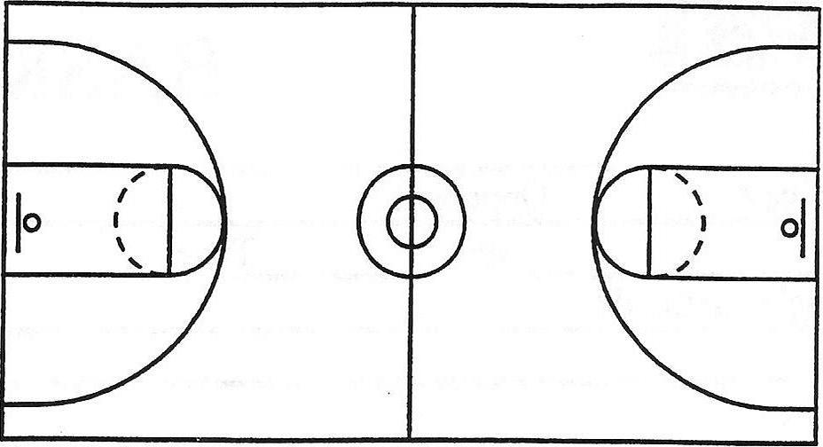
Drill Name:

Drill Name:

Notes:

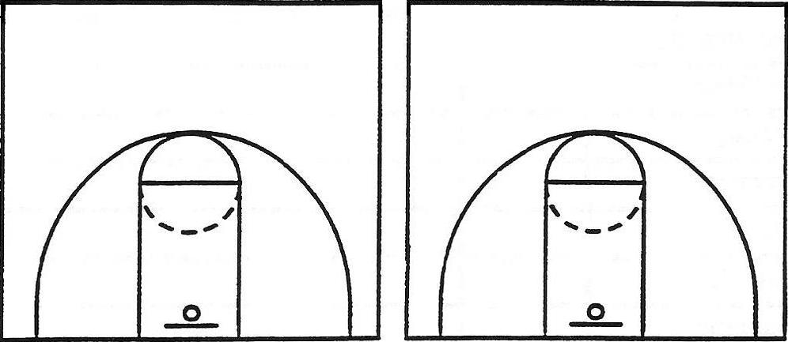
Notes:

Special Situations Special Notes Team Offense

Inbound Under Press Offense

Side Inbound Fast Break

Home Run Secondary Break

Situations Specials

Free Throw Defense Gimmicks

Free Throw Offense Team Defense

3 pt. Plays Man/Man

3 pt Defense Full court Half Court

Warning Match-up Gimmicks

Intentional Foul Zone Presses

