Forms prepared by Gary Schulte.

Team: |  |  | Date: Opponent:
# | Name | Height/Weight | Strengths | Weaknesses | Other Notes

Substitution patterns and impact:

Defensive changes and impact:

Miscellaneous comments (coaches tendencies, conditioning, etc.)

What will work against opponent:

What opponent may have success with against us:

Scouting: Half-court offense
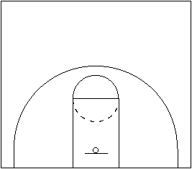 | 1
 | 2
 | 3
 | Half-court offense (continued) 4
 | 5
 | 6

Scouting: Half-court defense
1
2
3
Half-court defense (continued) 4
5
6

Scouting: Out of bounds
1
2
3

Scouting: Full-court pressure
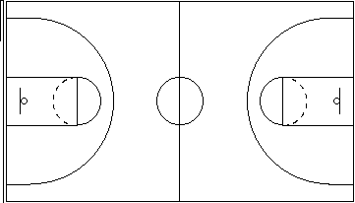 | 1
 | 2
 | 3

Scouting: Press breaks
1
2
3

